CHARLAN BROCK ARCHITECTS ELEVATES ALLEN DAPSON, CRAIG GARBARINI TO PARTNER
-Firm also appoints seven new associates-

MAITLAND, FL, April 10, 2018 – Charlan Brock Architects (CBA) recently named Allen Dapson and Craig Garbarini, AIA, LEED AP as partners of the 37-year-old Maitland-based firm.

Dapson, who has worked at CBA for 18 years, and Garbarini, who has worked at CBA for 23 years, both have served in project management functions overseeing many development projects during their tenure. Dapson received his Associate’s Degree in Architecture and Design from Seminole State College, and Garbarini holds a Master's in Architecture from the University of Illinois at Urbana-Champaign.

In addition to these promotions, CBA is also proud to announce the addition of seven new associates at the firm: Kathy Bridges, Tanner Brock, Taylor Brock, Steve Hammond, Sonia Portes, Mark Valentino, and Terri Willis.

Gary Brock, AIA, one of the founding partners of CBA, stated: “As our firm continues to grow and expand our footprint in the multi-family housing, mixed use, commercial, and resort/hotel development industries, it has long been a strategy of CBA to recruit and train the next generation of top-notch architects and designers. On behalf of all the principals of the firm, I can tell you we’re elated to be working alongside these talented individuals and know the future is in great hands.”

- MORE -

Charlan Brock Architects is an architectural firm that meets the changing needs of the broad multi-family, housing, and lifestyle center development industries. CBA has become the go-to firm for integrating housing of all typologies across the market spectrum, creatively designing financially successful products that are marketable and buildable. The company stays abreast of emerging trends, applying experience and knowledge in their consistent pursuit of excellence and innovation. CBA’s process is highly collaborative, developing close relationships with clients and outside consultants before, during, and after construction. For more information, visit cbaArchitects.com.
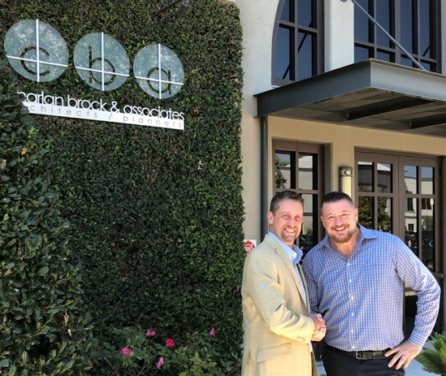
Photo Attached: Craig Garbarini, AIA, LEED AP (left) and Allen Dapson (right) were recently named partners at Charlan Brock Architects.

###

